**Getting started with Google Colab**

1. Go to the colab website (<https://colab.research.google.com/>), log in to your gmail account (or create an account if needed).
2. To create a notebook from scratch :

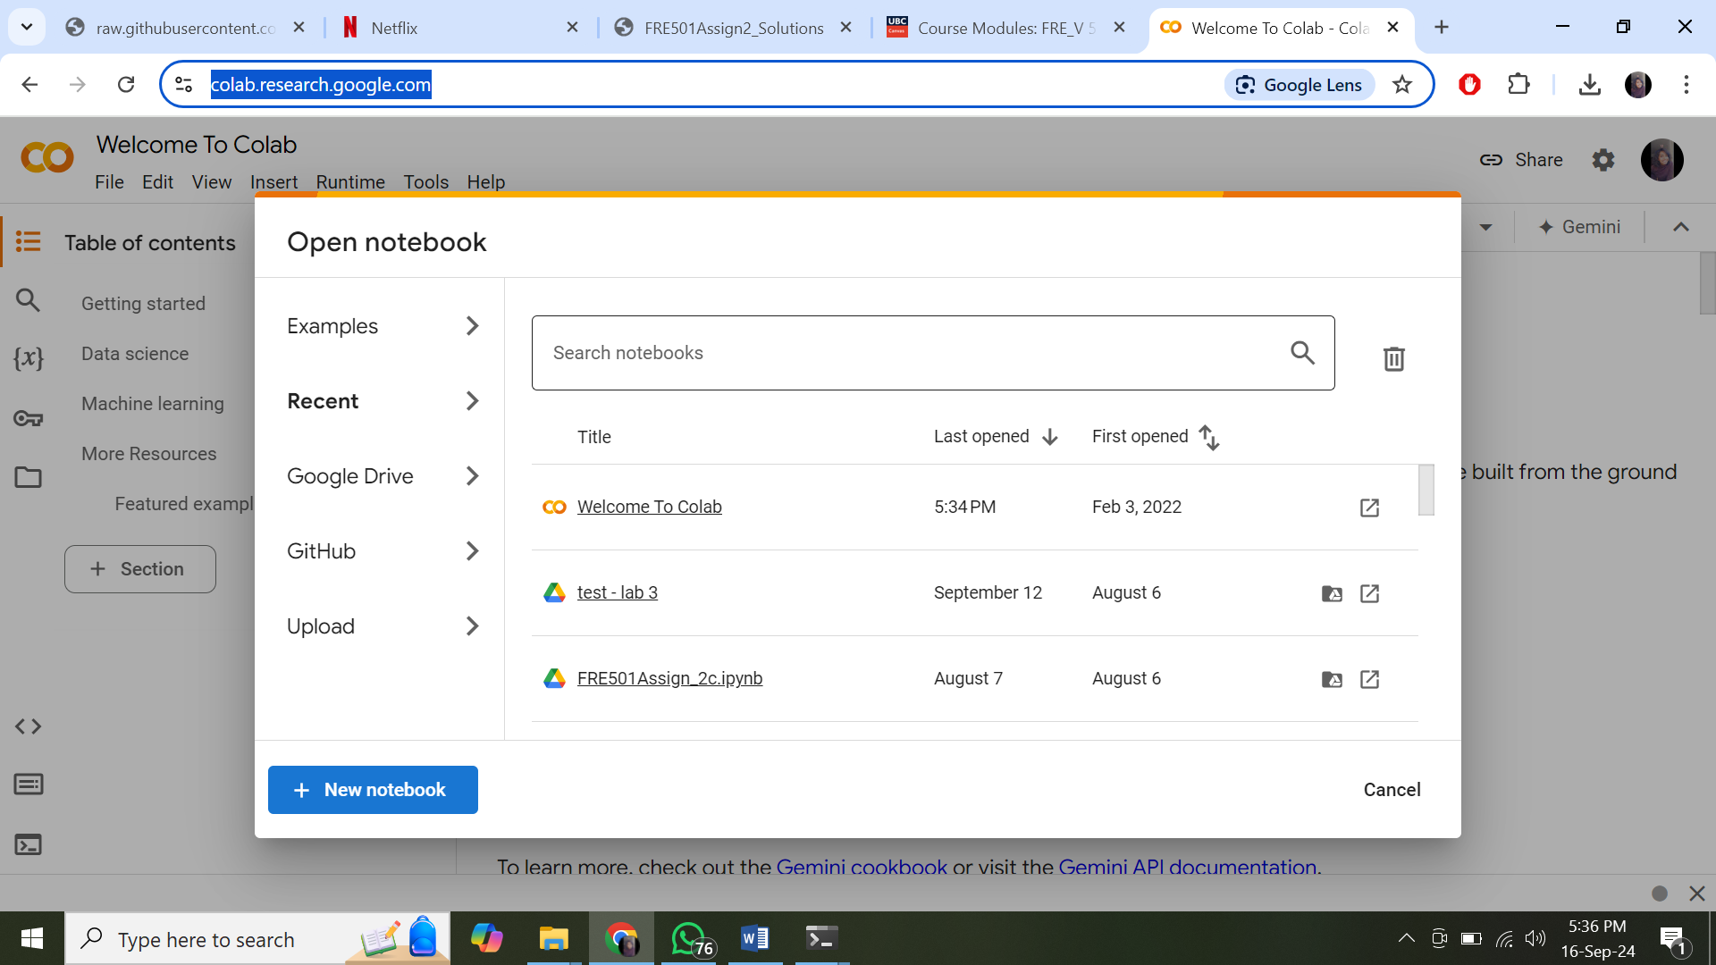

1. Else click on “Upload” and upload an existing .ipynb file from your system.
2. Ready to go!